# Report for Liam Bray (2024-10-01 to 2024-10-31)

Average Bat Speed: 37.27

Average Rotational Acceleration: 1.47

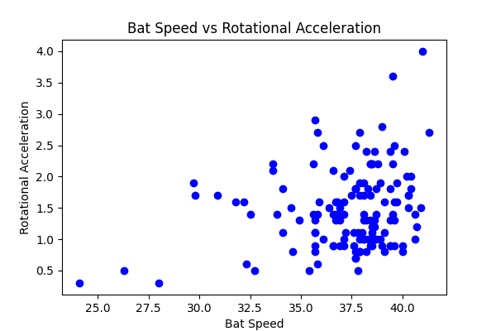

## Comments

Add comments here...